**Fundamental physics :**

Important topic:

**Resistors, capacitors, diodes, transistors, inductors,** **rectifiers**

**Power Electronics – AC/DC conversion**

Matter : matter is anything that has mass and take up space (volume) . Everything around us – air , trees , mobile phone , my body , solid , liquid , gas ( air , oxygen , stream)

Note – smallest unit of matter is atom

Not matter : light , heat , sound , energy they donot have mass and space

example : think matter is biggest wall . atoms are bricks it is building block that join together to make everything we see

Atoms are made of even **smaller particles**:

* + **Protons** (positive charge +)
  + **Electrons** (negative charge -)
  + **Neutrons** (neutral, no charge)

**Protons (+) → Positively Charged Particles**

* **Location:** Found in the **nucleus** (center) of an atom.
* **Charge:** **Positive (+)**
* **Role:** Determines the **identity** of an element.
  + Example: **Hydrogen (H) has 1 proton**, Oxygen (O) has **8 protons**.
* **Fact:** The number of protons in an atom is called the **atomic number**.

**2. Electrons (-) → Negatively Charged Particles**

* **Location:** Move around the nucleus in **energy shells/orbits**.
* **Charge:** **Negative (-)**
* **Role:** Responsible for **electricity and chemical reactions**.
* **Fact:** Electrons are much **smaller** and **lighter** than protons.

**3. Neutrons (0) → Neutral Particles**

* **Location:** Found in the **nucleus** with protons.
* **Charge:** **No charge (neutral, 0)**
* **Role:** Adds **mass** and helps keep the nucleus **stable**.
* **Fact:** Some elements have different numbers of neutrons, called **isotopes**.

**Simple Analogy: Atom as a Solar System 🌞**

* The **nucleus** (protons + neutrons) is like the **Sun** ☀️ at the center.
* **Electrons** move around the nucleus like **planets orbiting the Sun**.

Note- **protons** and **electrons**, which carry **electric charge**.

Electric charge : electric charge is a property of tiny particles inside atoms that make attract or repel each other .

It is make electricity work:

Two type of charges :

* **Positive charge (+)** → Found in **protons**
* **Negative charge (-)** → Found in **electrons**

**like charges repel, opposite charges attract:**

* Two **positives (+, +)** push away.
* Two **negatives (-, -)** push away.
* A **positive (+) and a negative (-)** pull toward each other.

**Unit of charge:** Coulomb (C)

* Example: An **electron** has a charge of **-1.6 × 10⁻¹⁹ C**.

**Question : "Rubbing a balloon on your hair transfers electrons, " i have question electron particle are transfer or charges (+,-) are transfer**

Soln: When you rub a balloon on your hair, **actual electron particles are transferred**, not just the charge.

Great question! When you rub a balloon on your hair, **actual electron particles are transferred**, not just the charge.

**Why?**

* Electrons (**negative charge carriers**) are **light and free to move** in many materials.
* Protons (**positive charge carriers**) are **locked inside the nucleus** and **cannot move**.
* So, when two objects rub together, **electrons move from one object to another**, causing a difference in charge.

**Example (Balloon and Hair):**

1. When you rub a **balloon on your hair**:
   * **Electrons from your hair move to the balloon.**
   * The balloon becomes **negatively charged (-)** (gained extra electrons).
   * Your hair becomes **positively charged (+)** (lost electrons).
2. Since **opposite charges attract**, your hair sticks to the balloon.

**Question: "Electric current is the flow of electric charge through a conductor. It is caused by the movement of electrons in a closed circuit due to a potential difference " in this statement flow of electric charge or flow of electron**

**Why do we say "flow of electric charge"?**

Electrons carry a negative charge and move through a conductor (like a wire).

charge is a property of electrons, we often say "flow of electric charge" instead of "flow of electrons."

in reality, the actual moving particles are electrons in most circuits

Important Concept: Conventional Current vs. Electron Flow

Electron Flow (Real Current) → Electrons move from negative (-) to positive (+) terminal of a battery.

Conventional Current → Historically, scientists assumed current flows from positive (+) to negative (-) (opposite to electron flow). Why use Conventional Current is not required it create so much confusion

He assumed that electric current was the movement of a positive charge from + to -.

Later, scientists discovered that electrons (negative charge) actually move from - to +

To avoid rewriting laws and equations, the industry kept using conventional current in circuit diagrams and analysis

Q_1: what is electric current ?

**Electric current is the flow of electron through a conductor. It is caused by the movement of electrons in a closed circuit due to a potential difference.**

Note : move electric charge means move electron ( - ve charge ) , proton(+ve charge ) it cannot move

**Static electricity is NOT a current** because the charges stay in one place until they discharge suddenly.

It occurs when two different objects **exchange electrons** due to friction, contact, or induction, creating an imbalance of charge.

**Dynamic electricity is the true electric current** because charges move continuously through a circuit.

**What is Potential Difference?**

**Voltage = Pressure**

**Potential difference** (also called **voltage**) is the **force** that pushes electric charges (electrons) to move in a circuit. It is like the "pressure" that drives electricity from one point to another.

* **Voltage (potential difference) = Electrical Pressure**
* **More voltage = More force pushing electrons**
* **No voltage = No flow of electricity**

**Simple Analogy: Water vs. Electricity**

Imagine a **water tank connected to a pipe**:

* If the tank is **full**, water flows fast (high pressure).
* If the tank is **half-empty**, water flows slower (low pressure).
* If there is **no height difference**, water doesn’t flow.

Now, think of a **battery in an electric circuit**:

* A **9V battery** has **high electrical pressure**, so it pushes electrons strongly.
* A **1.5V battery** has **less electrical pressure**, so electrons move slowly.
* If there is **no voltage difference**, electricity won’t flow.

**What’s Inside a Battery That Creates Electrical Pressure?**

A **battery** creates **electrical pressure (voltage)** using **chemical reactions** inside it. These reactions push electrons from one side to another, creating a **potential difference** between the terminals.

**How a Battery Creates Electrical Pressure (Voltage)?**

1. **Chemical reaction starts** → The anode releases **electrons**.
2. **Electrons cannot go directly to the cathode** (blocked inside).
3. **Electrons take the external path (circuit)** → If you connect a wire, electrons **flow through it** to reach the cathode.
4. This movement of electrons creates **electricity** that powers devices.

**Note: More chemical energy = Higher voltage (e.g., 9V, 12V batteries).**

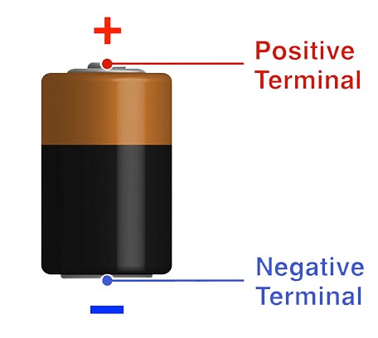

|  |  |
| --- | --- |
| **Resistance (R)** | **Opposition of flow of electrical current using a resistor.** |
| **Circuit** | **A closed loop or path through which electric current flows.** |

**What is Electronics?**

Electronics is the study of electrical circuits consisting of active electrical components such as transistors, diodes, [integrated circuits (*IC*)](http://www.mobilecellphonerepairing.com/ic-basic-tutorial.html),

**Electric Power :**

Electric power is how fast electricity is used or changed into another form like light, heat, or motion.

* **Voltage (V) = Water pressure** (pushes water/electricity).
* **Current (I) = Water flow** (amount of water/electricity flowing).
* **Power (P) = How fast the water turns a waterwheel** (how fast electricity does work)

EX; **Iron (1000W) 🔥**

* A **1000W iron** converts electricity into **heat** to press clothes.
* Since it has **higher wattage**, it **heats up faster** than a 100W bulb.

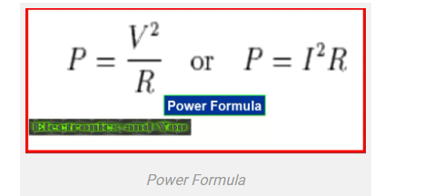

**Electronic Component :**

**Basic component :** Resistor , Capacitor , Transistor , Diode , Inductor , IC , Operational amplifier , logic gate .

**Passive component :**

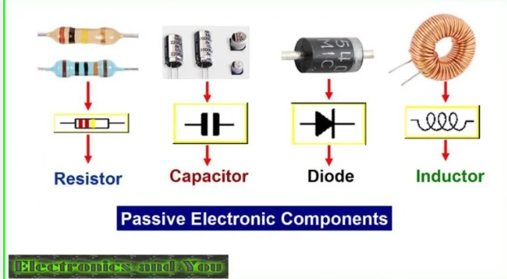

These components are those that do not have gain or directionality.

**Example**: Resistors, Capacitors, Diodes, Inductors.

**Active Components**

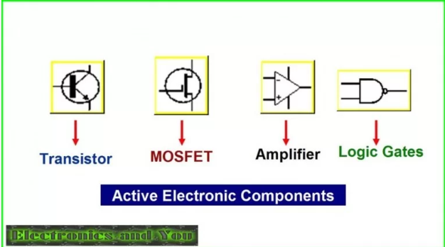

These components are those that have gain or directionality.

**Example**: Transistors, [Integrated Circuits or ICs](http://www.mobilecellphonerepairing.com/integrated-circuit-ic.html), Logic Gates, operational amplifier.

**Diode:**

Diode is a electronic device that conducts electricity only in one direction.

* Diode is made up of two word “DI” MEANS two and “ODE” means electrode ( cathode and conde).
* they are also used to change AC current to DC current.
* 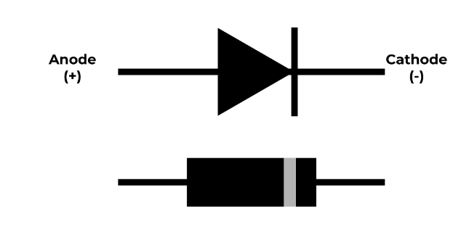

**Construction of diode :**

A diode is a two-terminal semiconductor device made from p-type and n-type semiconductor materials. It allows current to flow in one direction only and is widely used in rectifiers, LEDs, and circuits.

**How conductivity work :**

Atom in outermoset cell is called valence electron

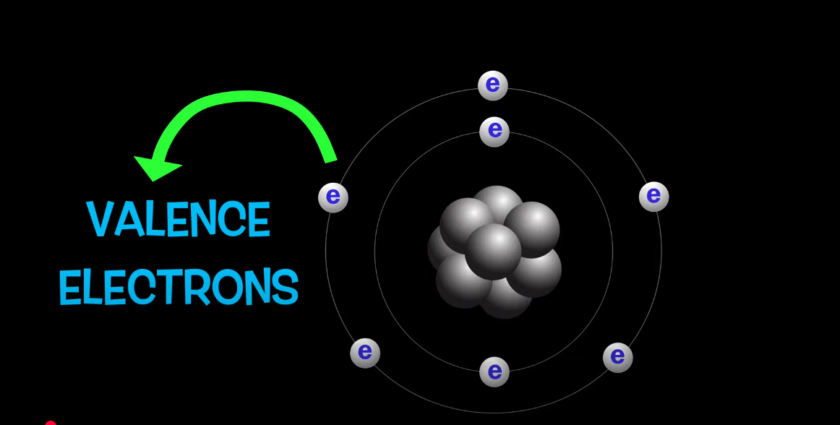

This valence band create a energy band :

**Why valence band create energy band:**

Multiple atom came closer outmost cell electron fell neighbour’s atoms nucleus attraction , then energy level shift it create energy band

In this energy band : electron can freely move in this energy and there is no gap band . this movement of electron create electricity

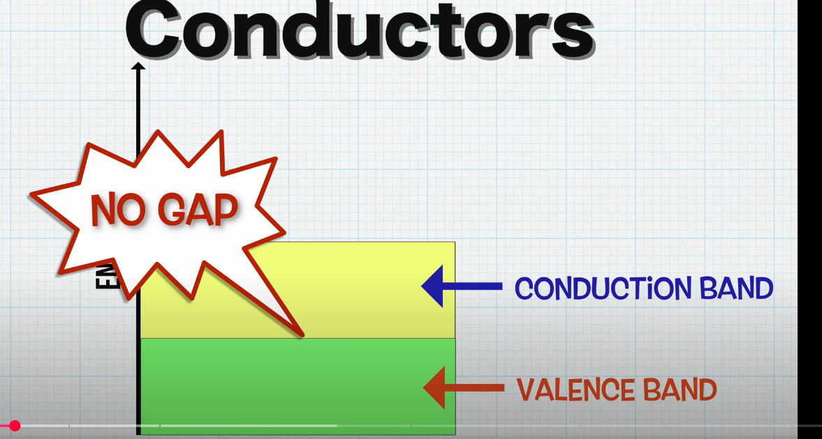

Valance electron can not reach conduction band , that’s why electricity passes through insulator

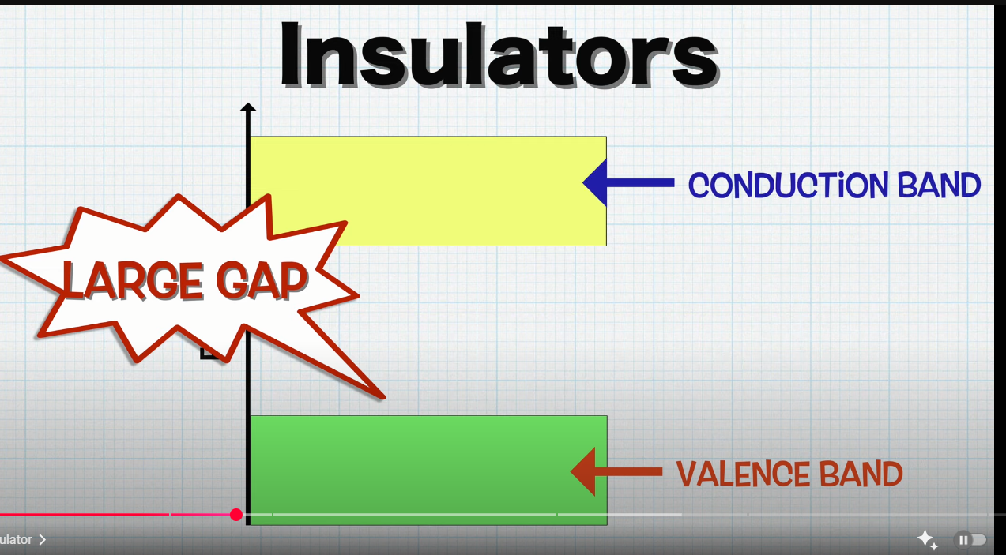

**Semiconductor :** an substance that properties between an insulator and conductor , electricity easily pass through semicondutor

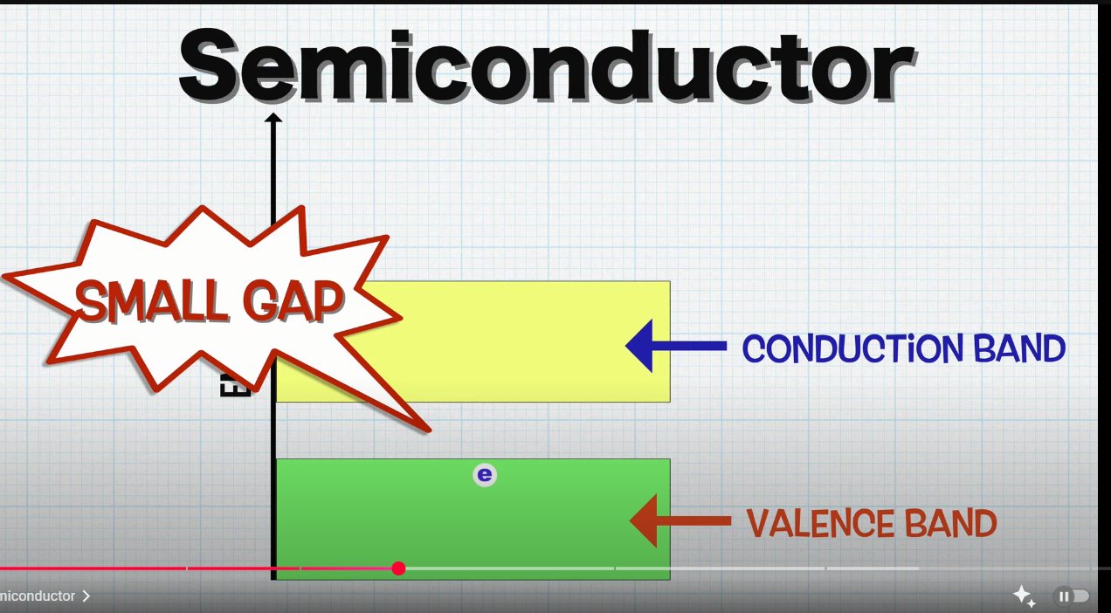

Intrinsic and Extrinsic semiconductor

Most widely used semiconductor : silicon and second germanium

**Used in electronic devices** like diodes, transistors, and microchips

Intrinsic semiconductor: if you want get electron from intrinsic heat them electron get out from valence cell

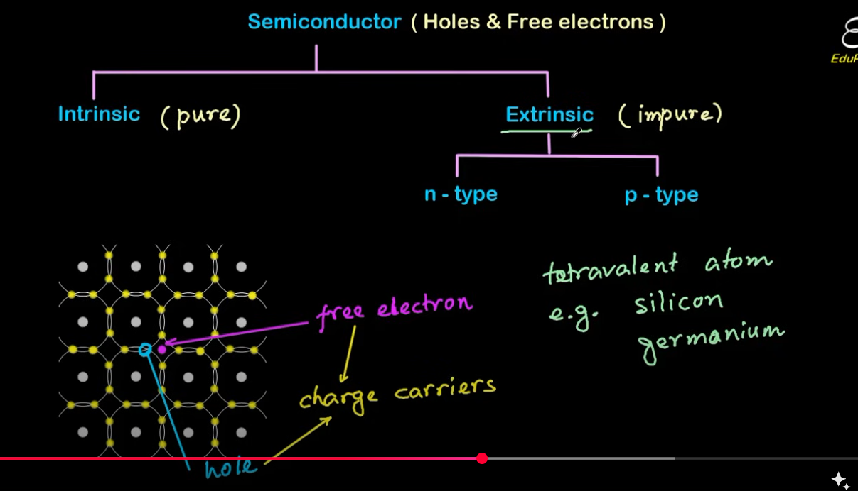

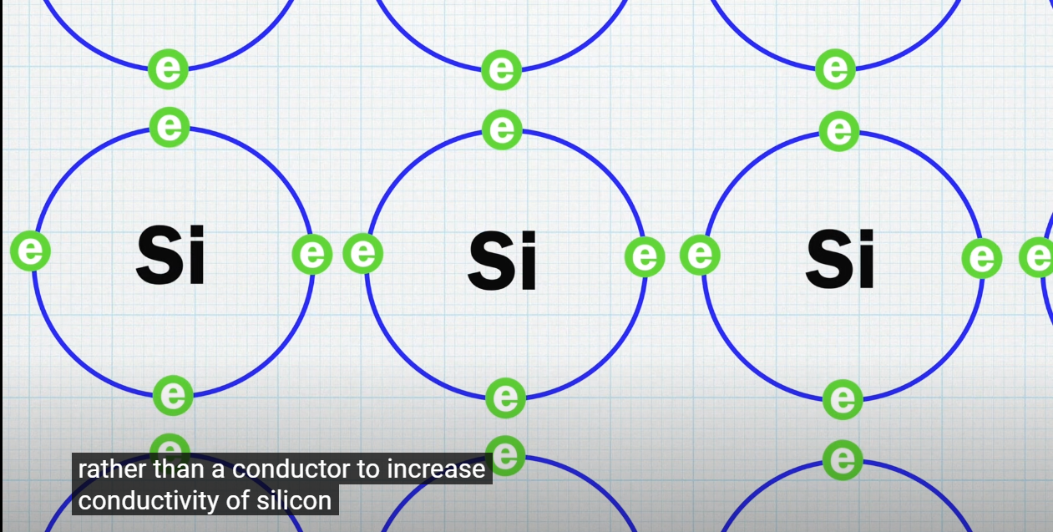

All silicon electron make bond with another silion atom so they canot move around this make pure silion crystal an insulator

***@#$%-Made of **pure silicon (Si) or germanium (Ge)** without any impurities.  
✔ Has an **equal number of free electrons and holes**, making it a **poor conductor** at room temperature.  
✔ **Example:** Pure silicon crystal.

**📌 How It Works:**

* At **low temperatures**, no free electrons → behaves like an **insulator**.
* When **heated**, some electrons gain energy and jump to the conduction band, creating **free electrons and holes** → increasing conductivity.

**Extrinsic SEMICONDUCTOR:**

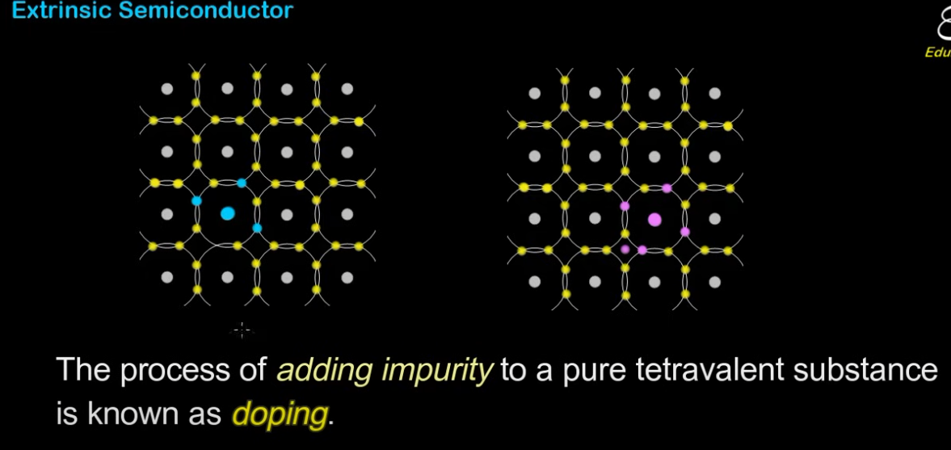

Doping : tetravalent ( 4 valance elcteron ) semiconductor me trivalent( 3 valence electron) or pentavalent(5 valence electron) add karte hai . enhe impurity add karna bhi bolte hai .

Note – valence cell ko stable karne ke lye 8 electron ki need hoti hai poly exculsive principle

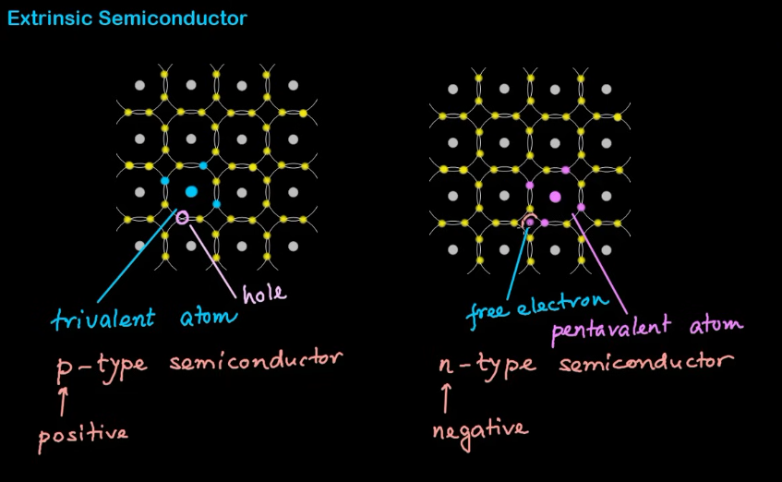

Note – impurity add very small amount . example : 10 lack tetravalent atom me 1 impurty add kar dena .

* If we add trivalent impurities in a semiconductor (Silicon and germanium), a greater number of holes are present and it is a positive charge. therefore this type of layer is known as the p-type layer.
* If we add pentavalent impurities in semiconductors (silicon or germanium), due to excess electrons there is a negative charge. therefore this type of layer is known as the n-type layer.

** if we combine n-type and p-type – it help to flow current in one direction is called diode

Free electron : flow electron -> create current

Hole : hole is treated as positive . jo electron flow kar rahe hote hai un ko trap kar leta hai , and apne neighbour ke elctron ko release kar deta hai . current ko flow karne me hole ka bhi role hota hai

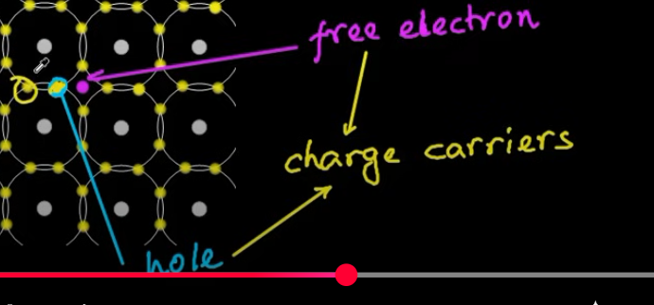

Important question

**What is a semiconductor?**

Soln:A semiconductor is a material that has electrical conductivity between a conductor (like copper) and an insulator (like rubber). Its conductivity can be controlled by temperature, impurities (doping), or an electric field, making it useful for electronic devices like diodes, transistors, and microchips.

**How Temperature Affects Semiconductor Conductivity:**

1. **Intrinsic Semiconductors**:
   * At absolute zero (0 K), intrinsic semiconductors (like pure silicon or germanium) behave as insulators because there are very few charge carriers (electrons and holes).
   * As the temperature increases, thermal energy excites some electrons from the valence band to the conduction band, creating electron-hole pairs. This increase in charge carriers enhances conductivity.

** semiconductor Its conductivity can be controlled by electric field important concept- transister , Field-Effect Transistors (FETs),  
2️⃣ **How does a semiconductor differ from a conductor and an insulator?**

**Insulator?**

| **Property** | **Conductor (e.g., Copper)** | **Semiconductor (e.g., Silicon)** | **Insulator (e.g., Rubber)** |
| --- | --- | --- | --- |
| **Conductivity** | High (many free electrons) | Moderate (controlled by doping) | Very low (almost no free electrons) |
| **Band Gap** | No band gap (overlapping bands) | Small band gap (0.6-1.2 eV) | Large band gap (>5 eV) |
| **Temperature Effect** | Increases resistance | Increases conductivity | Almost no effect |
| **Usage** | Wires, metals | Electronics, chips | Insulating covers |

3️⃣ **What are intrinsic and extrinsic semiconductors?**

**Soln:**

**Intrinsic Semiconductor (Pure)**

* Made of pure silicon (Si) or germanium (Ge) without impurities.
* Has equal numbers of electrons and holes, making it a poor conductor.
* Conductivity increases with temperature.

**✔ Extrinsic Semiconductor (Doped)**

* Impurities are added (doping) to improve conductivity.
* Two types: N-type (more electrons) and P-type (more holes).

4️⃣ **Explain N-type and P-type semiconductors.**

**N-Type (Negative Charge Carrier)**

* **Doped with a pentavalent element** (e.g., Phosphorus, Arsenic).
* Extra **electrons** are free to move → **better conductivity**.
* **Majority carriers = Electrons**.

✔ **P-Type (Positive Charge Carrier)**

* **Doped with a trivalent element** (e.g., Boron, Gallium).
* Creates **holes (missing electrons)** that attract electrons.
* **Majority carriers = Holes**.

**What is doping in semiconductors?**

Doping is the **process of adding impurity atoms** to a semiconductor to **increase its conductivity**.

* **Pentavalent atoms (P, As) → N-type (more electrons)**.
* **Trivalent atoms (B, Ga) → P-type (more holes)**.

6️⃣ **What are holes in a semiconductor?**

A **hole** is the **absence of an electron** in the valence band.

* Acts as a **positive charge carrier**.
* Moves when an electron fills the gap

7️⃣ **Define energy bands (valence band, conduction band, band gap).**

**Valence Band:**

* The **outermost energy band** where **electrons are bound to atoms**.
* Electrons in this band **do not conduct electricity**.

✔ **Conduction Band:**

* The **higher energy band** where **free electrons move and conduct electricity**.

✔ **Band Gap:**

* The **energy difference between the valence and conduction bands**.
* Determines if a material is a **conductor, semiconductor, or insulator**.

8️⃣ **Why Does Pure Silicon Behave as an Insulator at Absolute Zero?**

At absolute zero (0 K), all electrons are tightly bound in the valence band.  
✔ No free electrons → No conductivity → Acts as an insulator.  
✔ As temperature increases, some electrons jump to the conduction band, increasing conductivity.

**Give examples of semiconductor materials.**

* **Silicon (Si)** – Most widely used in electronics.
* **Germanium (Ge)** – Used in high-speed transistors

**Why do we use silicon and germanium as semiconductors?**

**Soln:**because of their unique electrical properties

Right Band Gap for Controlled Conductivity

 cheap and widely available.

Easy Doping for Better Conductivity

**Working of Diode:**

In a diode, the N-type side has lots of free electrons, while the P-type side has lots of holes (which are like missing electrons). Because there are more electrons on the N-side and more holes on the P-side, some electrons move from the N-side to the P-side, and some holes move from the P-side to the N-side. When they meet, they cancel each other out.

This movement creates a small empty region near the middle where no free charge carriers (electrons or holes) are left. This area is called the Depletion Region

Depletion layer create a electric field layer , potential barrier .

**potential barrier** in a diode is the built-in voltage that forms across the **depletion region** and prevents further movement of charge carriers.

**How It Forms:**

* When electrons from the **N-type** side move to the **P-type** side and combine with holes, a region with no free-moving charge carriers is created (the **depletion region**).
* This region contains **immobile ions**—negative ions on the P-side and positive ions on the N-side—creating an **electric field**.
* This electric field opposes further movement of electrons and holes, forming a **potential barrier** or potential diffrence

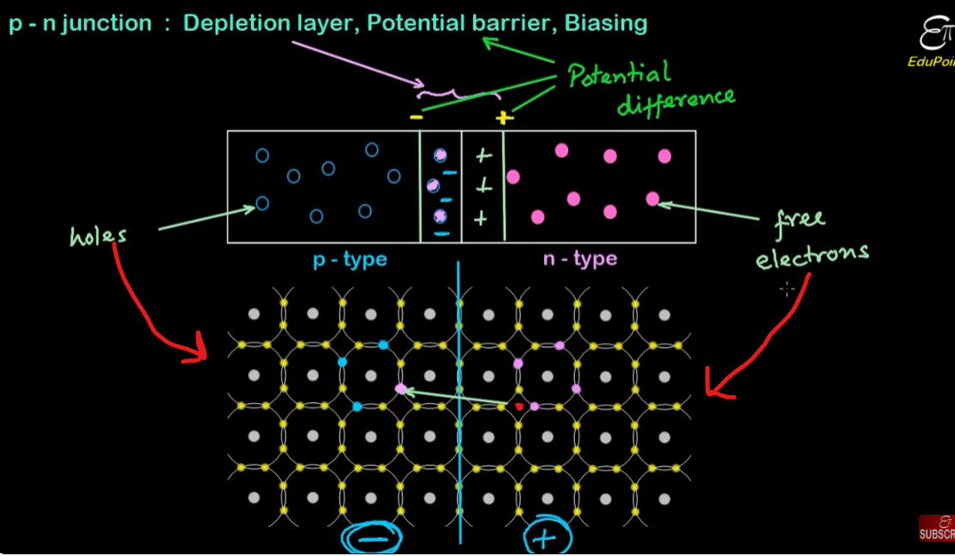

**Forword biasing :**

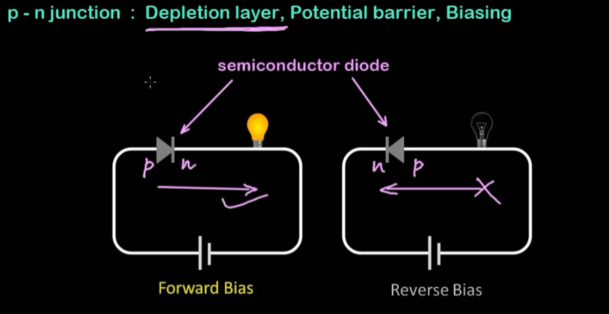

**Depletion region ke Electron saare positive terminal me aa jaynege due to attraction and n-type ke electron depletion region**

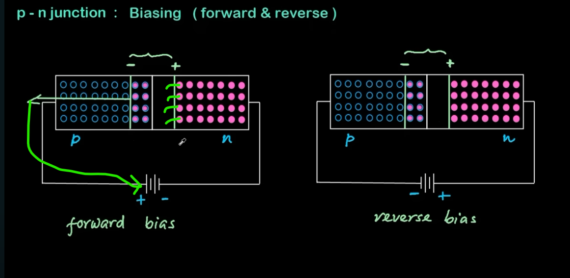

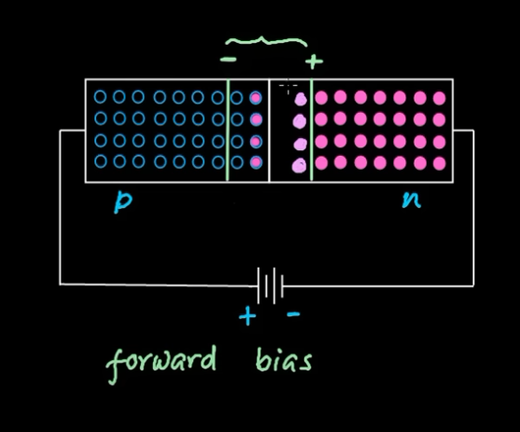

Depletion region patla hota jaega aur current flow hota jaeyga

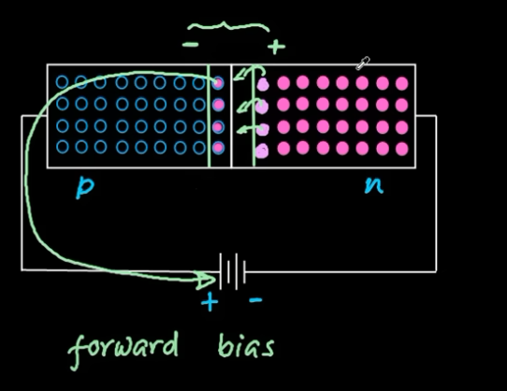

Reverse biasing

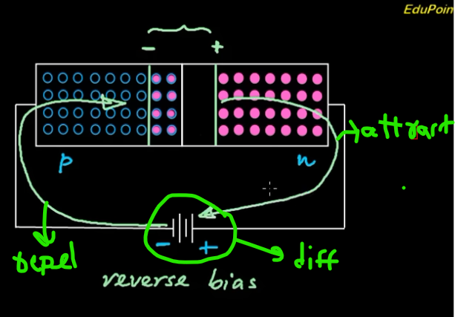

-ve terminal ki taraf electron delpletion region ko repel karega but vo positive terminal ke hole ko electron se fill kar dega

+ve terminal electron ko attract karega electron sarre move hokar +ve me aajaynge

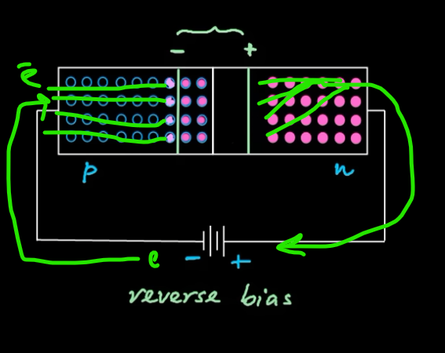

Depletion region increase hota jaeyga and potential difference bhi increase hoga

Depletion region k electron kabhi bhi +ve terminal per nahi aa paynege becose region incerese ho gya .

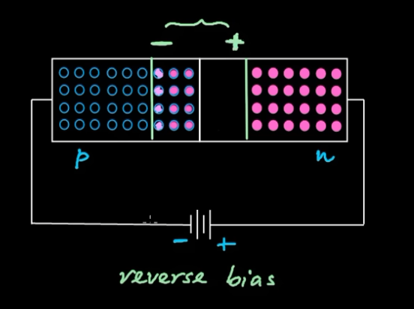

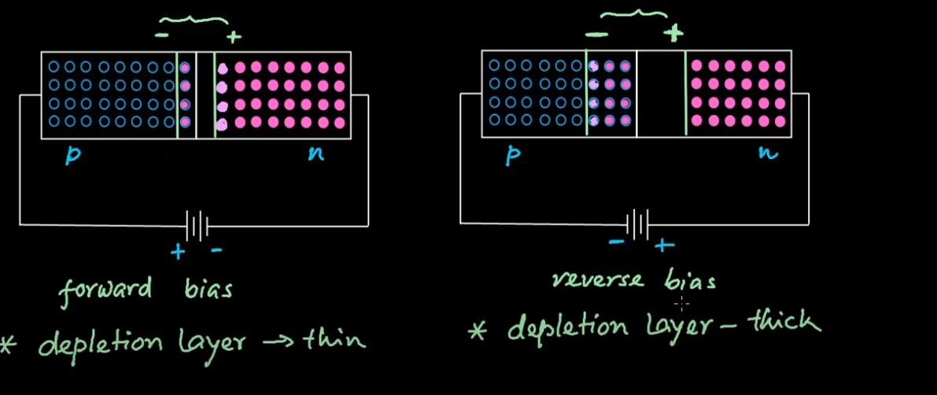

Type of semiconductor diode :

* LED: LED is also called a Light Emitting Diode
* P-N Junction Diode
* Zener Diode

[P-N junction diodes](https://www.geeksforgeeks.org/p-n-junction-diode/) also called rectifier diodes are used for the rectification process. In a P-N junction diode, two layers of semiconductors materials are used. For a P-N junction diode, one layer is made of P-type semiconductor material and the other layer of N-type material. The combination of these two layers forms a junction known as the P-N junction. Thus, the name comes P-N junction diode.

The current in the P-N junction diode flows in the forward-biased condition and blocks in the reverse-biased condition.



**Transistor :**

A transistor is a semiconductor that control voltage or current flow in electronic signal and it amplify and acts as switch .

Eg.

If the transistor is working as an amplifier then it transforms a small input current into a big output current.

Parts of transistor:

* **Base:**To activate the transistor
* **Collector:**Positive lead of transistor
* **Emitter:** Negative lead of transistor

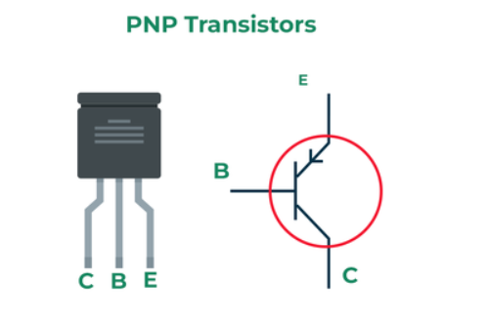

**Types of Transistors**

* **Bipolar Junction Transistor**
* **Field effect transistor**
* **Bipolar Junction Transistor (BJT)**

**Bipolar Junction Transistor (BJT):** It can able to amplify the electrical signal by joining all three layers into one.

The BJT can be further classified as PNP and NPN Transistor

Npn:

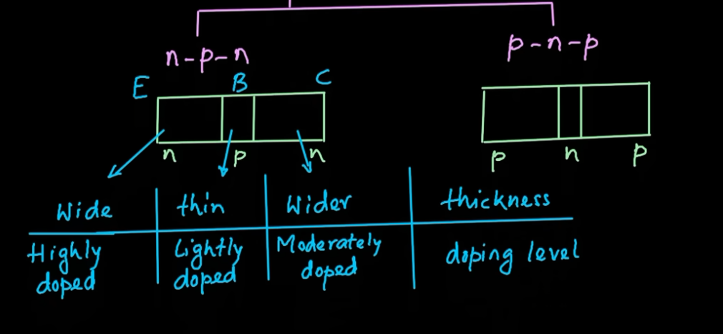

Forward bias:

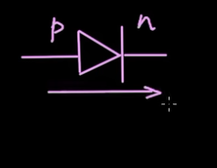 current and electric field direction are same

Reverse bias

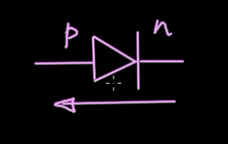 electric field opposite direction of current direction electricity not flow

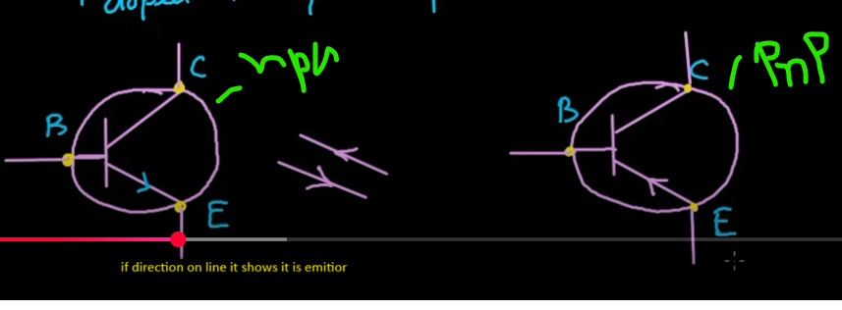

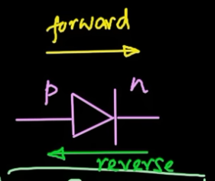

Reverse biasing opposite to electric field

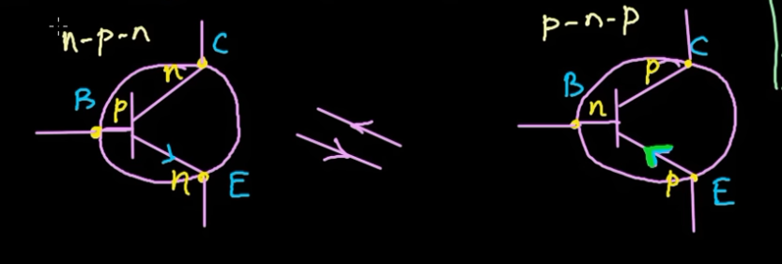

Physics behind transistor:

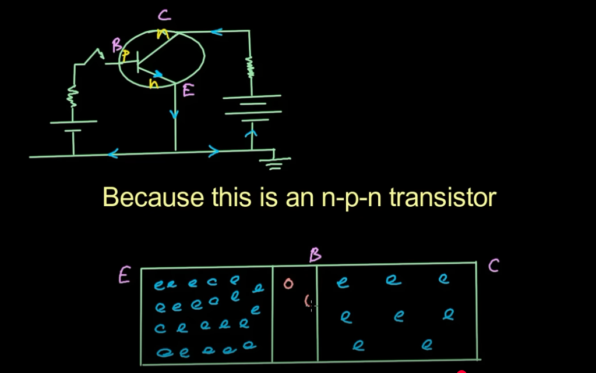

****holes are less in base if we increase holes transistor did not work

** electron flow opposite to electric field

** direction of current and the direction of electron flow are opposite

** when **positive and negative charges** are present, an **electric field** is created due to their attraction.

